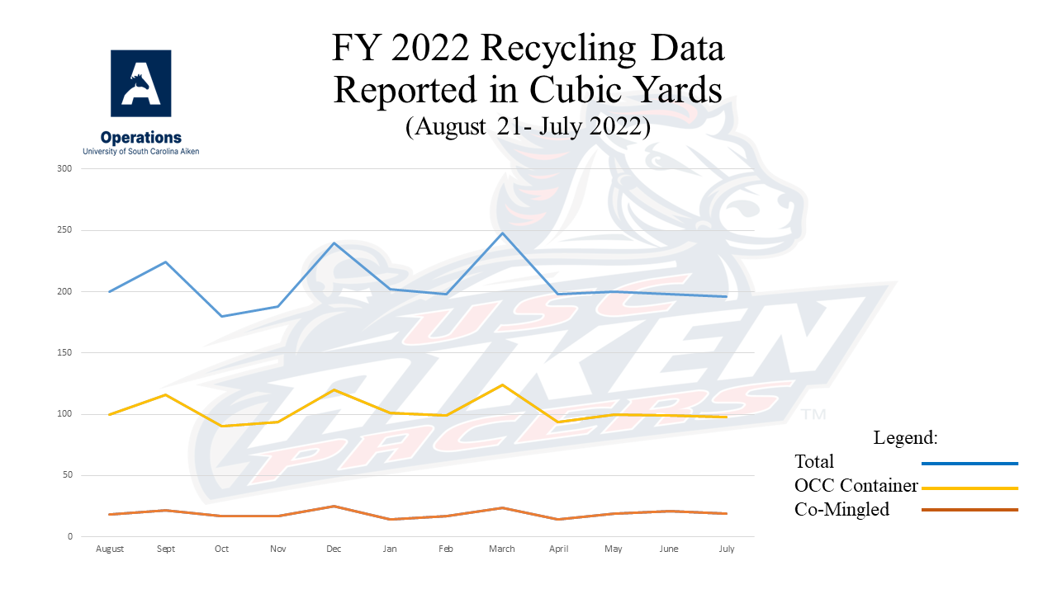

**What's Recycled at USC Aiken?**

USC Aiken is now recycling the following items:

* Mixed paper
* Cardboard
* Aluminum cans
* Plastic bottles
* Styrofoam peanuts

**Mixed Paper**

Mixed Paper includes all of the following:

White Paper, Colored Paper, Newspaper, Magazines, Catalogs, Junk Mail, Telephone Books, Pasteboard, Greeting Cards, Postcards, Post-it Notes, Brochures, Pamphlets, Hardcover Books (bagged separately), and posters (no glitter, paint, or crayon).

*\*\*Staples in the paper are acceptable, but do not leave paper clips or jumbo clips on the paper.*

*\*\*Spiral notebooks can be discarded as well as long as the metal spiral has been removed.*

***Mixed paper does NOT include :***

Any type of cover or insert that is vinyl coated or wax coated!

**Cardboard**

When recycling cardboard, the following steps should be taken:

1. All materials in the box (i.e., paper, Styrofoam peanuts, plastic wrap, etc.) should be emptied out of the box first.
2. All cardboard should be broken down by opening the bottom flaps before discarding it.
3. You can dispose cardboard at any time in the green 30yd container between the baseball field and the tennis courts, but if you should need help or have any questions regarding this, you can contact the Environmental Health and Safety Manager.

**Plastics**

For all plastics recycling on campus, the caps to plastic bottles must be removed and placed in the regular trash before the plastic bottle can be disposed of in the gray container with gray lids designated for plastics recycling. Remember, we take type 1 and 2 plastics only!

**Aluminum Cans**

All aluminum cans should be thrown into the designated red containers with gray lids. Please try to empty the cans before disposing of them.

**Styrofoam Peanuts**

All Styrofoam packing peanuts can be recycled by collecting them and taking them to the Bookstore. If you have any questions regarding this, please contact the Bookstore at extension 3457.

**Types of Recycling Containers on Campus**

**Blue Containers**

Blue recycling containers are placed in various departmental offices around campus, and these containers are used for recycling **mixed paper only**.

**Bag-it Systems**

Bag-it Systems are located in various computer labs on campus, and these containers are used for recycling **mixed paper**.

**Red Containers**

Red recycling containers are placed in various locations around campus mainly in hallways of buildings, and these containers are used for recycling**aluminum cans only**.

**Gray Containers**

Gray recycling containers are placed in various locations around campus mainly in hallways of buildings, and these containers are used for recycling **plastic bottles only**. All caps must be removed from the plastic bottles before they can be recycled.

**Indoor Recycling System**

Indoor recycling centers have been placed in the H&SS Building to evaluate their effectiveness on campus. These centers will have collection areas for **trash, mixed paper, aluminum cans, and plastic bottles**. If these recycling centers have the desired effect, then additional centers will be placed around campus as funds are available.

**Outdoor Recycling System**

Outdoor recycling centers have been placed in the Quad area. These centers have collection areas for **trash, aluminum cans, and plastic bottles.**

**30 Yard Mixed Paper Container**

All **mixed paper** that is collected on campus is placed in this 30 yard container located in the loading dock area of the library.

**30 Yard Cardboard Container**

All **cardboard** is collected in this 30 yard container located between the baseball field and the tennis courts. However, cardboard can be recycled by placing it with the trash for housekeeping.

**Locations of Recycling Containers**

|  |  |
| --- | --- |
| **Blue Office Containers** | **Administration Bldg** Admissions (Rm 101H) Advisement & Career Services (Rm 107) Economic Development (Rm 110) Institutional Effectiveness (Rm 108) Office of the Registrar (Rm 109) Mathematics (Rm 227) Psychology (Rm 226) Computer Services (Rm 236)  **B&E Building** Conference Center & Continuing Education (Rm 100) Counseling Center (Rm 126) Assistive Technology Center (Rm 134) Education (Rm 210) Business (Rm 222) 2nd Floor Copier Wellness Center (Rm 20C)  **Children's Center** Office  **Etherredge Center** Ticket Office  **Gregg-Graniteville Library** Copiers  **H&SS Bldg** Office Suite 101 Suite 204 |
| **Bag-it Systems** | **Administration Bldg** Psychology Computer Lab (Rm 214) Math Lab (Rm 221)  **B&E Bldg** Computer Lab (Rm 238)  **H&SS Bldg** Writing Room (Rm 112) Pacer Times (Rm 110) Language Lab (Rm 107) Computer Classroom (Rm 106)  **Nursing Bldg** Computer Lab (Rm 136)  **Student Activities Center** Student Life Office  **Science Bldg** Computer Lab (Rm 101)  **Indoor Recycling System**  **H&SS Bldg (Only)** Across from Rm 106, Rm 109, Rm 116, Rm 203, and Rm 210 Nursing Bldg Office (Rm 101)  **Pacer Downs** Office  **Alumni House** Chancellor's Office External Affairs Development & Alumni Affairs  **Ruth Patrick Science Education Center** Workroom (Rm 109) Workroom (Rm 213) Workroom (Rm 312)  **Science Bldg** Biology/Geology (Rm 201) Academic Affairs/Chemistry & Physics (Rm 214)  **Student Activities Center** Athletics Office Student Life Office Bookstore Food Services  **Supply & Maintenance Bldg** Office |
| **Red Containers & Gray Containers**  (Both are grouped together in all locations.) | **Administration Bldg** Courtyard by Auditorium (Rm 106) 2nd Floor Hallway by Rm 215 2nd Floor Hallway by Rm 234  **Etherredge Center** Vending Area near Rm 140  **B&E Bldg** 1st Floor hallway by Rm 131 1st Floor hallway by Rm 136 2nd Floor hallway by Elevator 2nd Floor hallway by Rm 236  **Student Activities Center** Quad side entrance Parking Lot A entrance  **Ruth Patrick Science Education Center** 1st Floor hallway by lunchroom 2nd Floor hallway by Rm 214 3rd Floor hallway by Rm 313  **Nursing Bldg** Rm 122 Hallway by Rm 114  **Science Bldg** 1st Floor hallway by Rm 105 2nd Floor hallway by Rm 214 |

The following are important questions and answers you might have regarding recycling on campus:

**What is considered mixed paper that I can recycle in my box?**

White paper, Colored paper, Newspaper, Junk mail, Telephone books, Pasteboard (i.e., cereal boxes), Hardcover books, Catalogs, and Magazines are all considered recyclable paper. Hardcover books must separated and bagged before disposal. The only exceptions are any type of cover or insert that is vinyl coated or wax coated. If you can not tear it, it is not paper!!!

Staples in the paper are ok, but do not leave paper clips, jumbo clips, or the like on the paper. Spiral notebooks can be discarded as well as long as the metal spiral has been removed. Posters with ink and magic marker are fine to recycle, but poster with paint, glitter, Styrofoam, and crayon are NOT recyclable.

**Should I bag my paper before I dispose of it?**

No, the paper to be recycled should be placed in all containers loose. No paper should be bound by rubber bands, string, or plastic bags. Only hardcover textbooks should be placed in bags before recycling.

**When housekeeping collects the paper from our blue recycling containers, what happens to the paper?**

Housekeeping will pick up the paper from the blue recycling bins and place the paper at a central location within their building assignments. Two housekeepers have partial responsibility to recycling efforts on campus, and they pick up the recycled materials from the various locations on campus three times a week (Monday, Wednesday, and Friday) placing it in the appropriate container for dumping.

**My office generates a significant amount of cardboard, but how should we dispose of it?**

The university does recycle cardboard as well, and the container to collect the cardboard is located between the tennis courts and the baseball field. The following steps should be taken when recycling cardboard:

1. All materials in the box (i.e., paper, styrofoam peanuts, plastic wrap, etc.) should be emptied out of the box first
2. All cardboard should be broken down by opening the bottom flaps before discarding it.
3. You can dispose cardboard at any time, but if you should need help or have any questions regarding this, you can contact me at [**LenE@usca.edu**](mailto:LenE@usca.edu).

**How many types of plastics are there, and what types do we recycle on campus?**

There are actually seven different types of plastics that can be recycled. See the chart below for the different types of plastics and examples of each. However, we only accept **type 1 and 2 plastics**in our recycling program!

|  |  |
| --- | --- |
| PET Recycling Code 1 | **PETE Polyethylene Terephthalate**- Soft drink, beer, and Two-liter beverage bottles, mouthwash bottles, boil-in-bag pouches. |
| PE-HD Recycling Code 2 | **HDPE High Density Polyethylene**- Milk jugs, water and juice containers, trash bags, detergent bottles, yogurt and margarine tubs. |
| PVC Recycling Code 3 | **V Vinyl (sometimes seen as PVC, for polyvinyl chloride)**- Cooking oil bottles, packaging around meat |
| LDPE Recycling Code 4 | **LDPE Low Density Polyethylene**- Grocery bags, produce bags, food wrap, bread bags. |
| PP Recycling Code 5 | **PP Polypropylene**- Yogurt containers, shampoo bottles, straws, margarine tubs, diapers. |
| PS Recycling Code 6 | **PS Polystyrene**- Hot beverage cups, take-home boxes, egg cartons, meat trays |
| O Recycling Code 7 | **OTHER**- All other types of plastics or packaging made from more than one type of plastic. |

**Where are the recycle containers for the paper, aluminum cans, and plastic bottles located on campus?**

The blue recycling containers are located in most departmental offices by a copier or a printer or in an office workroom. All paper is eventually disposed of in a large container by the library.

Aluminum cans should be disposed in the red containers found in various locations around campus. These are for cans only, so please pay careful attention when discarding of your trash. All aluminum cans are ultimately disposed of in plastic bags in the large container by the library as well.

Plastic Bottles can be disposed of in the gray containers on campus, the indoor recycling centers located in the H&SS Building, and the outdoor recycling centers in the Quad area. However, the caps should be removed from all plastic bottles before they are disposed. The caps to the plastic bottles should be thrown into the regular waste.